Modulo 3 ecomerce

Permiso eventbridge en lambda
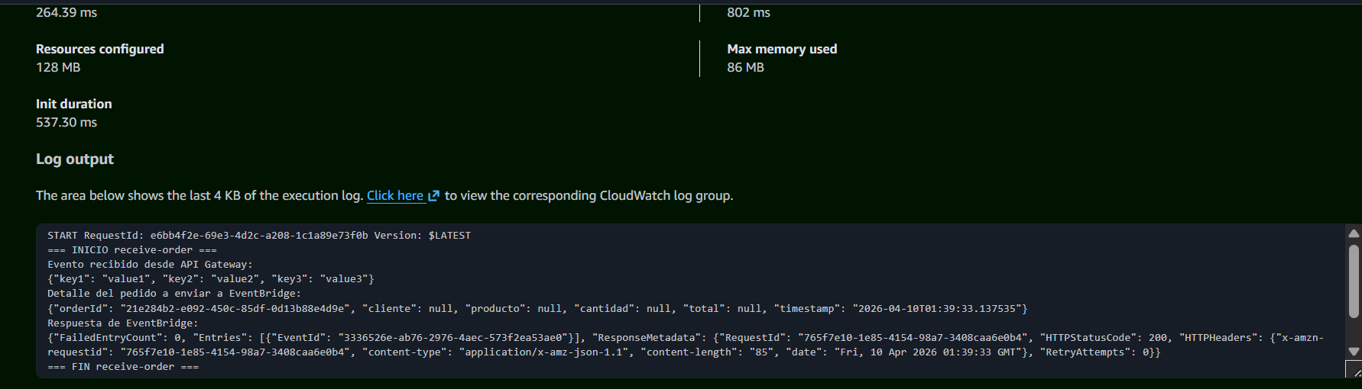
receive-orden-josemanuel
validate-order-josemanuel
check-inventory-josemanuel
process-payment-josemanuel
confirm-order-josemanuel
register-auydit-josemanuel

eventbridge
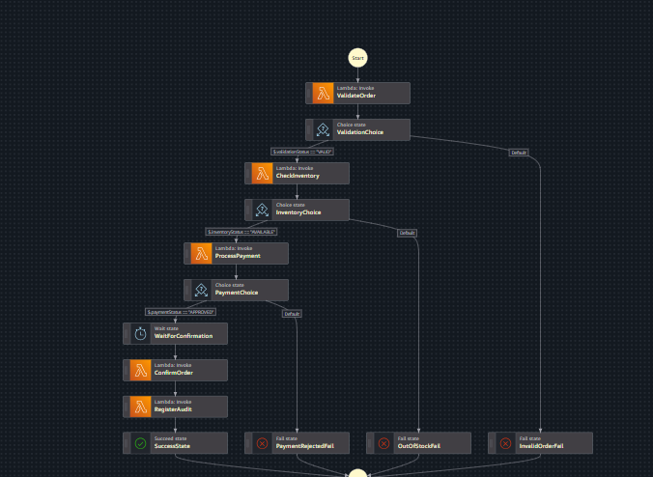
Role step
Amazon_EventBridge_Invoke_Step_Functions_1958106694
